**New Patient Questionnaire- aged 16 and over**

Our practice brochure is available to download via our website.

Log on to www.pinfoldmedicalpractice.co.uk to find out more information on our practice.



**We are asking you to complete this questionnaire in order to respond to your needs and enable us to offer our patients the best service we can.**

**All information you provide is confidential and will be used to register you with the practice.**

**Title: Miss / Mrs / Ms / Mr / Dr or Other (Please state):** ______________

**Forename(s):** ____________________________ **Surname:**

**Address:** ________________________________________________________________________________

**Residential Status: ___________________________**

*For example lives at home/homeless etc*

**Email Address:** ___________________________________________________________________________

**Telephone Number: Mobile Number:** ­­­­­

**Date of Birth: Gender:** Male  Female 

**NHS Number:**________________________________

|  |  |
| --- | --- |
| ❑ | **Please tick if you consent to being contacted by SMS/mobile**  *This is particularly useful for appointment reminders* |
| ❑ | **Please tick if you consent for us to leave you an answerphone message** |

**Name of Next of Kin:**

**Address/Telephone Number:**

**Relationship to you:**

**Do you care for somebody?** Yes / No

*A carer is a friend/ family member who gives their time to support a person in their home, to an extent that the person could not remain at home if this care was not being provided.*

**If yes, do you look after someone who is a patient at Pinfold Medical Practice?** Yes / No

**If yes, what is their name and relationship to you: _________________________**

**______________________________________________________________________________**

**Do you require a carer to assist you?** Yes / No

Contact details:

**Do you have a named social worker?** Yes / NO

Contact details:

**Do you consent for your carer/Social worker to be informed about your medical care?** Yes / No

**Are you looking after someone else’s child?** Yes / No

**If yes, under what arrangements: (Circle please)**

Section 20 – Voluntary Care Interim Care order Care Order

Child arrangement order/Residence Order Special Guardianship Order

Placed for adoption Private arrangement/Private fostering/Informal arrangement

*(Please note you have a duty to notify social care of this arrangement)*

|  |
| --- |
|  |
|  |
|  |

|  |  |  |  |  |  |
| --- | --- | --- | --- | --- | --- |
| **What is your ethnic origin?** | | | | | |
| British (9i0)  | | Irish (9i1)  | Other White background(9i2) | | |
| White & Black Caribbean(9i3) | | White & Black Asian (9i4)  | White & Asian (9i5)  | | |
| Other Mixed background (9i6) | | Indian / British Indian(9i7)  | Pakistani/British Pakistani (9i8) | | |
| Bangladeshi/British Bangladeshi (9i9) | | Any other Asian background (9iA)  | Caribbean (9iB)  | | |
| African (9iC)  | | Any other Black background (9iD) | Chinese (9iE)  | | |
| Other ethnic category  *Please state:* | | | | | |
| I do not wish to answer (9iG)  | | | | | |
| **What is your main spoken language?** | | | | | |
| English  | Hindu  | | | | Gujurati  |
| Bengali  | Punjabi  | | | | Somali  |
| Urdu  | Arabic  | | | | Polish  |
| Romanian  | Hungarian  | | | I do not wish to answer  | | |  |
| Mandarin  | Cantonese  | | | Other  | | |  |
| Do you require an interpreter?  Yes  No  | | | | | |

**Are there any types of treatments/medication you cannot have due to religious beliefs?** Yes / No *If yes, please state below:*

**Do you have any allergies**? Yes / No *If yes, please state below:*

**Have you had any adverse reactions to medicines or substances?** Yes / No *If yes, please state below:*

**Do you have any needs relating to disability, impairment or sensory loss?** Yes/No

*If yes, please state your preferred method of communication:*

|  |  |
| --- | --- |
| **Smoking status:** Current smoker / Ex-smoker / Never smoked | |
| If you are a current smoker, what is your daily consumption? per day | **If you are a current smoker, have you thought about stopping recently?**   **Yes**  **No**  **If you would like help, please ask for details from Reception or contact STOP on 0845 0452828** |
| If you are an ex-smoker, when did you stop?  Date stopped: |
|  | |

|  |
| --- |
| **WOMEN ONLY** (please complete) |
| **Have you had a hysterectomy?** Yes / No  *If yes, please provide date:* |
| **Have you had a cervical smear?** Yes / No  **If yes, what was the date of your most recent one?**  **And what was the result?** Normal / Abnormal / Don’t know |

**Patient Details**

|  |
| --- |
| **Patient Height:**  **Patient Weight:**  **BMI:** |

**On average, please state how many units of alcohol would normally drink every week?**

Name: ________________________________ D.O.B: ________________ Units per week: ________

AUDIT – C – Brief Alcohol Questionnaire:

|  |  |  |  |  |  |  |
| --- | --- | --- | --- | --- | --- | --- |
|  | Scoring System = 0,1,2,3,4 | | | | | |
| Questions | 0 | 1 | 2 | 3 | 4 | Your Score |
| How often do you have a drink containing alcohol? | Never | Monthly  or less | 2 - 4 times per month | 2 - 3 times per week | 4+ times per week |  |
| How many units of alcohol do you drink on a typical day when you are drinking? | 1 -2 | 3 - 4 | 5 - 6 | 7 - 9 | 10+ |  |
| How often have you had 6 or more units if female, or 8 or more if male, on a single occasion in the last year? | Never | Less than monthly | Monthly | Weekly | Daily or almost daily |  |
| *Total Score* | | | | | |  |
|  | | | | | | |

**Scoring:** A total of 5+ indicates increasing or higher risk drinking.

**If you have scored 5+ Please complete the remaining questions below.**

|  |  |  |  |  |  |  |
| --- | --- | --- | --- | --- | --- | --- |
| Questions | 0 | 1 | 2 | 3 | 4 | Your Score |
| How often during the last year have you found that you were not able to stop drinking once you had started? | Never | Less than monthly | Monthly | Weekly | Daily or almost daily |  |
| How often during the last year have you failed to do what was normally expected from you because of your drinking? | Never | Less than monthly | Monthly | Weekly | Daily or almost daily |  |
| How often during the last year have you needed an alcoholic drink in the morning to get yourself going after a heavy drinking session? | Never | Less than monthly | Monthly | Weekly | Daily or almost daily |  |
| How often during the last year have you had a feeling of guilt or remorse after drinking? | Never | Less than monthly | Monthly | Weekly | Daily or almost daily |  |
| How often during the last year have you been unable to remember what happened the night before because you had been drinking? | Never | Less than monthly | Monthly | Weekly | Daily or almost daily |  |
| Have you or somebody else been injured as a result of your drinking? | No |  | Yes, but not in the last year |  | Yes, during the last year |  |
| Has a relative or friend, doctor or other health worker been concerned about your drinking or suggested that you cut down? | No |  | Yes, but not in the last year |  | Yes, during the last year |  |
| *Total Score* | | | | | |  |

Remaining AUDIT questions:

**Scoring:** 0 – 7 Lower risk, 8 – 15 Increasing risk,16 – 19 Higher risk, 20+ Possible dependence

**This practice uses Electronic Prescribing**

**What does this mean for you?**

* You will not have to visit the practice to pick up your paper prescription. Instead, we will send it electronically to the place you choose, saving you time.
* You will have more choice about where to get your medicines from because they can be collected from a pharmacy near to where you live, work or shop.
* You may not have to wait as long at the pharmacy as there will be more time for your repeat prescriptions to be prepared before you arrive.
* You can cancel or change the nomination at any time, either at the practice or nominated pharmacy.

**You may also choose for certain prescriptions not to be sent via this system, but please inform your GP or practice team member.**

**Unfortunately at this time Controlled Drugs cannot be sent electronically.**

If you wish to take this service up, you need to choose where you want your GP to send your electronic prescription. This is called ‘NOMINATION’.

**Name and Address of my nominated pharmacy:**

In accordance with General Data Protection Regulation, the practice needs consent if you are happy for a third party to collect prescriptions, test results and other medical information on your behalf. Please complete this section if you would like to register a third party.

I give consent for to collect prescriptions on my behalf (please note that we are unable to hand out prescriptions to anyone under the age of 16.

I give consent for to obtain test results/ medical information/ appointment information on my behalf (Delete as appropriate)

**IT IS YOUR RESPONSIBILITY TO ADVISE US OF ANY CHANGES TO THESE INSTRUCTIONS**

Signed: Date:

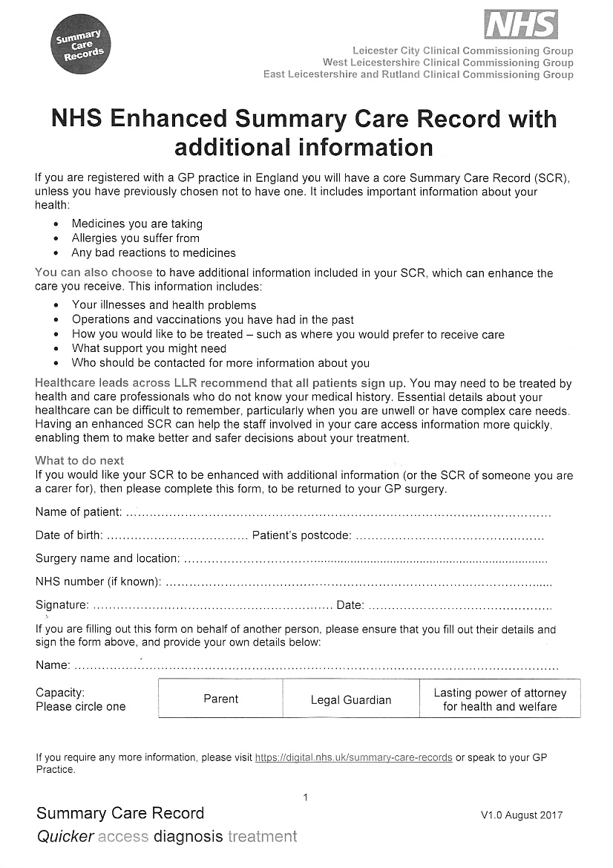

**Important information for you and your health records – Summary Care Record**

As you are registered with this practice, we would like to recommend that you take advantage of the Summary Care Record (SCR). It includes important information about your health: Medicines you are taking; allergies you suffer from, and bad reactions to medicines.

**More information can be found by visiting** [**www.nhscarerecords.nhs.uk**](http://www.nhscarerecords.nhs.uk)

**You MUST choose one of the following:**

- Express consent for Core SCR (medication, allergies and adverse reactions only)

- Express consent for medication, allergies, adverse reactions, **AND** additional information

- Express dissent for SCR(opt out) – I do not want a Summary Care Record

**Your registration**

Please return these forms to the surgery in person, with a form of Photo ID and a letter dated within the last 4 weeks as proof of address to confirm you are living within the practice boundaries.

Acceptable forms of ID

* Passport
* Driving Licence
* Provisional Licence

Proof of Address

* Utility Bill
* Bank Statement
* Rent Agreement Letter
* Solicitors Letter

Filling out the forms

* If you have been registered at another GP surgery before please contact them to obtain you ***NHS number*** and ensure you add their ***details (name and address of previous practice)*** to the purple form attached.
* If you are coming from abroad and have never registered with a GP, ensure you fill out the ***dates you arrived in the UK.***
* If you are returning from abroad fill the purple form in on the ***dates you left the UK and the dates you returned. Pleas also fill out your last known UK address, NHS number and your GP practice from when you were registered in the UK before you went abroad.***

Without these details we may not be able to register you.

**COVID 19 AMENDMENTS TO REGISTRATIONS.**

Currently the have been changes in how we will register you with the practice.

1. If you have been registered with a GP surgery before, we are not requiring any forms of identification. *You will need your NHS number to be able to register with us.* If you do not provide one, we will not accept your registration.
2. Patient who have never had an NHS number or have never been registered with the NHS will need to provide photocopies of ID and Proof of address.

When returning your completed form to Pinfold Medical please post it through our letter box, which is allocated in between the right side of the front entrance and the wall.