**Pinfold Medical Practice Newsletter – Spring 2023 edition.**

Contents

New! on-line appointments with acute care practitioners 1

Invite to prostate cancer awareness workshop 1

Teaching the next generation of doctors 2

Medical Student Feedback 2

Get involved, have your say 3

Other available services 3



# New! on-line appointments with acute care practitioners

Practice Prescribers treat all new symptoms once over the counter medication has been tried.

If you have an acute (new) symptom, you can now book on-line. Choose the appointment titled ‘Acute Care Practitioner face to face’.

For more information on acute symptoms treated by the acute care practitioners visit: <https://pinfoldmedicalpractice.co.uk/clinics-services/>

To book an appointment visit: [www.nhs.uk](http://www.nhs.uk)



# Invite to a prostate cancer awareness workshop

The Patient Participation Group, in conjunction with Prostaid, invite you to attend a workshop at the practice to raise awareness so that prostate cancer is spotted earlier and can be treated effectively:

**Thursday 16th March 2023**

**12-1pm**

**Alternatively, join via MS Teams:**

[Click here to join the meeting](https://teams.microsoft.com/l/meetup-join/19%3ameeting_MWNjY2FlNDItMzM2MC00ZWRjLWJmODYtNmQwYmQ0MGM5Zjg2%40thread.v2/0?context=%7b%22Tid%22%3a%2237c354b2-85b0-47f5-b222-07b48d774ee3%22%2c%22Oid%22%3a%2274d62330-73c5-46e0-a762-b96398a59d38%22%7d)

Meeting ID: 331 382 438 811   
Passcode: Uyu9QK

[Download Teams](https://www.microsoft.com/en-us/microsoft-teams/download-app) | [Join on the web](https://www.microsoft.com/microsoft-teams/join-a-meeting)

PROSTaid is a local Charity formed in 2006 with a positive attitude to prostate cancer. Their aim is to continue to improve treatments and save lives. For more information visit: [Home - Prostaid](https://www.prostaid.co.uk/)

# Teaching the next generation of doctors

In recognition of her work, Dr Jacqueline Green (Practice Partner) has been awarded the title of Honorary Senior Lecturer for her involvement in the teaching of undergraduate University of Leicester Students.

This includes leading the Charnwood Academy which supports Practices within the area to teach our future Doctors.

We asked Dr Green to tell us more about this important work:

“I teach Students within tutorials and in practice, imparting knowledge, and real-life experience to develop their consultation skills. I am an examiner at the University and also am in consultation with the University regarding placement development and recruiting new tutors and Practices, into the teaching community.

It would not be possible without our patients agreeing to see our students and for that I thank them. It is important that Students have clinical exposure to develop their competencies and there is no better way to learn than from our Patients. After all we are training the Doctors of tomorrow and they will be looking after me when I am older!

# Medical Student Feedback

The practice has an excellent reputation regarding its teaching programme, clinical education and supervision of Nottingham and Leicester undergraduate student.

At the end of their placement, Medical Students give feedback on their experience at the practice as whole. Below are the comments received during 2022-2023:

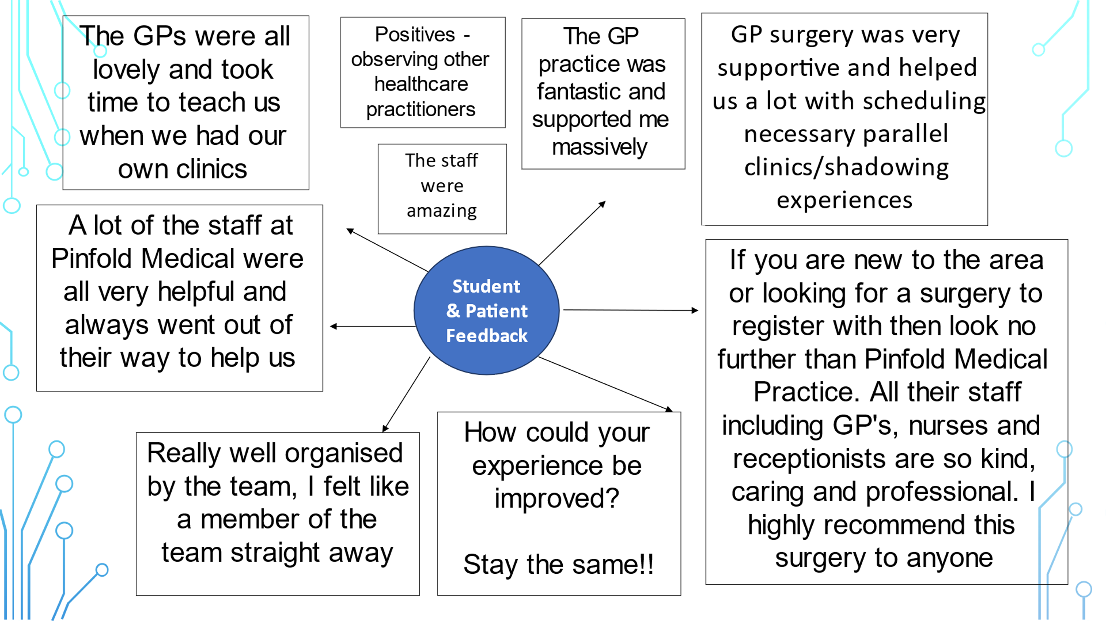

# Get involved, have your say

If you have ideas and suggestion on how to improve the NHS, GP practice and local services why not join the Patient Participation Group. Members are registered patients who volunteer their point of view as representatives of the wider patient population**.** (See above for details on the next meeting).

Rate the practice via the ‘Friends and Family test’ at [www.pinfoldmedicalpractice.co.uk](http://www.pinfoldmedicalpractice.co.uk)

Or, place your written suggestion in the practice letterbox.

Responses are featured in the ‘You said, We did’ section of the practice newsletters.

# Other available services

* **Self-care** information: [pinfoldmedicalpractice.co.uk](https://pinfoldmedicalpractice.co.uk/self-care-resources/)
* **Pharmacy First** over the counter medications are available from your local pharmacy
* **Repeat medication** on-line ordering service is available via the NHS app: [www.nhs.uk](http://www.nhs.uk)
* **NHS on-line symptom checker** for health advice: [111.nhs.uk/](https://111.nhs.uk/)
* **Support for Carers** of vulnerable and elderly: [support-for-carers-leicestershire/](https://vasl.org.uk/services/support-for-carers-leicestershire/)

[ageuk.org.uk/](https://www.ageuk.org.uk/)

[.alzheimers.org.uk/](https://www.alzheimers.org.uk/)

[Home (claspthecarerscentre.org.uk)](https://claspthecarerscentre.org.uk/)

* **First contact** plus offer social, health and financial support. Click here for more information <http://www.firstcontactplus.org.uk/about-us/>
* **Mental Health Central Access Point**

If you need urgent NHS mental health support, call our Mental Health Central Access Point: 0808 800 3302

24/7 Freephone helpline for people of all ages in Leicester, Leicestershire and Rutland

* **Therapy** for stress, anxiety and depression is available at [nhs.uk/psychological-therapies-service/](https://www.nhs.uk/service-search/find-a-psychological-therapies-service/)
* **Self-Referral Physiotherapy Service**

To book a telephone consultation with a physiotherapist call :**0300 300 0046**

Monday to Friday 08:00 to 16:00

# 