Frequently Asked Questions: Appointments
This leaflet has been designed in conjunction with the Patient Participation Group to answer the most frequently asked questions regarding appointments:
Q: Where to go and who to see for my problem?
Care navigators (also known as reception) ask for a brief description of the problem to get the most appropriate clinician.
Acute (new) problems are initially treated through self-care and consultation with your local pharmacist. Following this, the acute care practitioners in-practice can prescribe for minor ailments.
Chronic (ongoing / long term) problems are treated by the doctors.
The NHS diagram below shows the pathway to choosing well, when unwell.
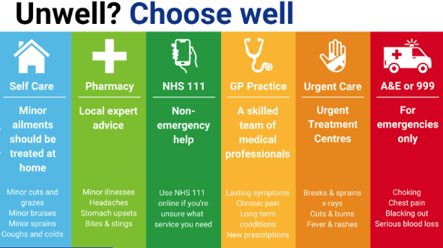NHS: resource
Q: How to book an appointment with the local pharmacist?
- Walk in to your local pharmacy; alternatively, reception are also able to refer for same day service.
Q: How to consult a GP online?
For medical advice online or to request administration such as a prescription or sick note.
‘Contact us’ at www.pinfoldmedicalpractice.co.uk
The practice receives your information in email format and will be responded to with the most appropriate advice for your problem.
This will be read by a member of the team within 2 working days
If you need more urgent help, call your GP. If your GP practice is closed, visit NHS 111 online or call 111. In an emergency call 999
Q: How to book routine appointments?
Nurse, acute care practitioner, physiotherapist and GP appointments can be booked via:
- NHS APP (for access visit www.nhs.uk) or Patient Access (visit reception with a form of photo ID)
- A booking link sent via SMS
- Reception desk or telephone 01509 220960

Q: What types of consultation are available?
- Face to face consultation
- Telephone (options to communicate via photo/video links may be offered by the consulting clinician, as appropriate)
- Emergency / On-call doctor assesses your immediate medical needs and advises accordingly).
For urgent advice when the practice is closed, call 111.
Alternatively, visit WWW.NHS111.UK for free expert health information and advice 24 hours a day.
Call 999 for life threatening emergencies.

Q: How do I cancel an appointment?
Appointments can be cancelled via:
- NHS APP or Patient Access (24/7)
- 01509 220960, option 2 (24/7)
- Reception (during practice opening times)

Q: How do I access the NHS APP?
To use the NHS App, you must be aged 13 or over and registered with a GP surgery in England.
The NHS APP links to your medical record giving you access to book GP appointments, order repeat prescriptions etc.
For further information, visit WWW.NHS.uk

Q: Can I book appointments for someone else?
Proxy access is often used by the parents or recognised carers of young children, and recognised carers of adults.
Proxy access allows someone other than the patient to book appointments and access parts of their GP online services account. The proxy is given their own online access account (rather than using the patient’s login details).
For further information visit NHS England » How proxy access works

Q: How do I arrange a home visit
Symptoms are assessed over the telephone prior to a GP or acute visiting service (paramedic) attending or, in some cases, you may be required to attend the surgery so as not to delay treatment and receive appropriate investigation.

Q: Why can’t I see my usual doctor?
There are a number of reasons why your usual doctor may not be routinely available.
- Senior doctors supervise medical students in consultation. This is essential for the future of the NHS.
- Emergency / on-call duties
- Annual leave
- Continuity is prioritised for Gold Standard, housebound and end-of-life patients.

Q: Can I get test results without an appointment?
Once results are returned from the lab, the doctor comments on them. This is a generic comment such e.g. ‘book a routine appointment’.
An invitation is sent via SMS text with an appointment booking link, alternatively reception contact patients via telephone. Due to the sheer volume of test results coming in, the practice doesn’t follow-up normal results.
Results can be checked via your NHS APP, online access account or by calling reception on 01509 220960.

Appendix of services:

What is Pharmacy First?
Pharmacists offer advice and prescribe medication for the following minor ailments and conditions:
✓ Cough ✓ Cold ✓ Sore throat
✓ Fever ✓ Earache ✓ Thrush
✓ Teething ✓ Threadworms
✓ Blocked nose ✓ Hayfever
✓ Athlete’s foot ✓ Diarrhoea
✓ Cold sores ✓ Skin rashes
✓ Eye infections ✓ Mouth ulcers

What is a Social Prescriber?
Social Prescribers offer support for the following:
✓ Loneliness and social isolation
✓ Finance, debt and benefit advice
✓ Housing / environment advice
✓ Education, training and employment
✓ Mental health and wellbeing
✓ Long Term Conditions advice
✓ Smoking cessation
✓ General health / fitness / lifestyle support
For further information or to self-refer, visit www.pinfoldmedicalpractice.co.uk

What is an Acute Care Practitioner?
Acute Care Practitioners prescribe for acute (new) symptoms.

They are the first clinical point of contact for all acute (new) symptoms, when over-the-counter medication has not resolved the problem.

They interpret results and refer to hospital consultants as per the clinical needs.

What is an MSK physiotherapist?
The practice musculoskeletal physiotherapist consults regarding bone and muscle conditions. They offer in-house physiotherapy and refer for X-ray and MRI scans as per the clinical needs of the patient.

What is a Health Care Assistant?
The Practice Health Care Assistant (HCA) takes blood tests and records patients’ base health readings such as height, weight and blood pressure.
Some have additional skills to apply dressings, check INR blood levels and perform diabetic foot checks.
Patients with long-term or chronic condition(s) need their repeat medications monitoring yearly. For this, the HCA takes base health readings for their annual MOT. The results are followed up with the practice nurse, in-house specialist nurses and doctors.

Other FAQ information leaflets available at www.pinfoldmedicalpractice.co.uk
- Consultations & referrals
- Prescriptions
- Telephones
- Reception & waiting room

